**PSI Written Test Instructions**

Log into: **Faa.psiexams.com 4/17/2020**

Select the website titled: **“PSI – True Talent Enterprise – psi exams**

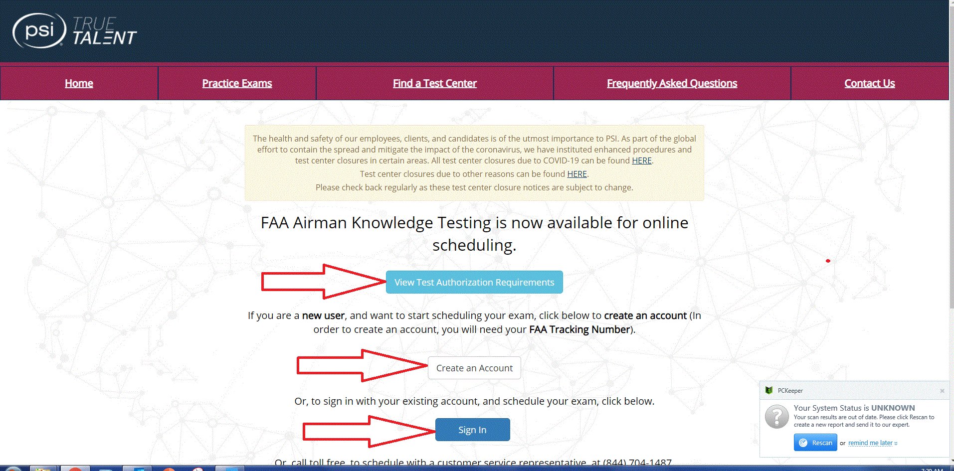

* **“View Test Authorization Requirements”**
  + Selecting this tab provides an applicant with information concerning the REQUIREMENTNS for taking a specific exam.
* **“Create an Account”** 
  + If the applicant hasn’t previously created an account with PSI, select this tab and log into their PSI and create an account.
  + hey will need to do this in order to log in and schedule an exam.
* **“Sign In”**
  + If the applicant has already created and account, select this tab and log into their PSI Account.

To **“Create an Account”,** enter the information requested on the **“Verify Your Eligibility”** page.

* FAA Tracking Number is your - **FTN tracking number**.
* **Create** a Username & Password on the next page.
* **Select** from the right hand sde of the page the exam you would like to take.
* When completed – **Press Continue**

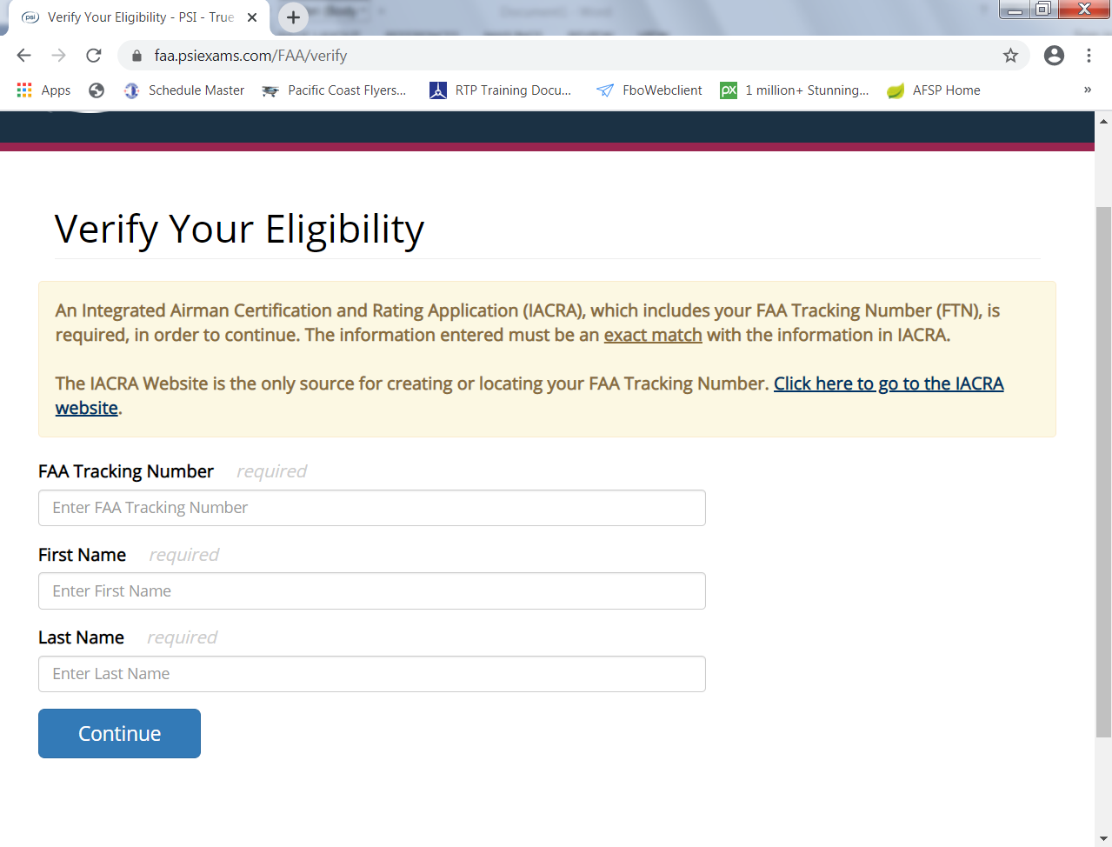

The system will take you to this page and will automatically default to the **“SELECT”** section.

**“SELECT”** – Click on this title to schedule a new or retake exam.

**“ACTIVE”** - Clink on this title to access any scheduled test you have proviously schedule but not taken. completed tests.

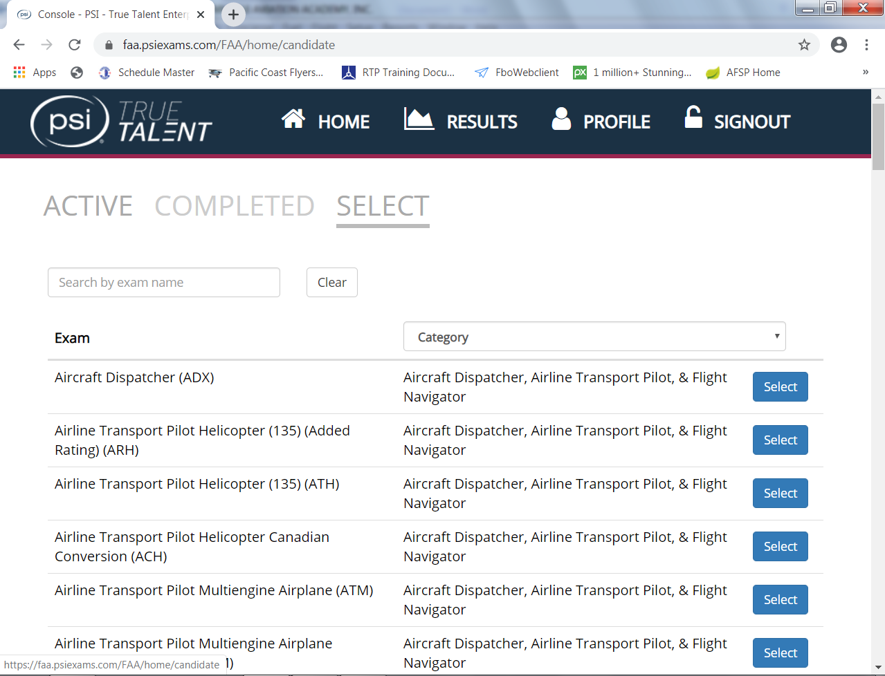**“COMPLETED”** – Clink on this title to access all prievously completed tests.

The system will take you to the **“Exam Data Collection”** page:

* **“Number of Exam Attempts”** section:
  + Enter number of attempts for a specific exam you have selected.

(If this is your first attempt – Enter 1 in the space provided.)

* **“Authorization Category”**
  + If your written test requires and endorsement, (most do) select the appropriate option from the dropdown box.

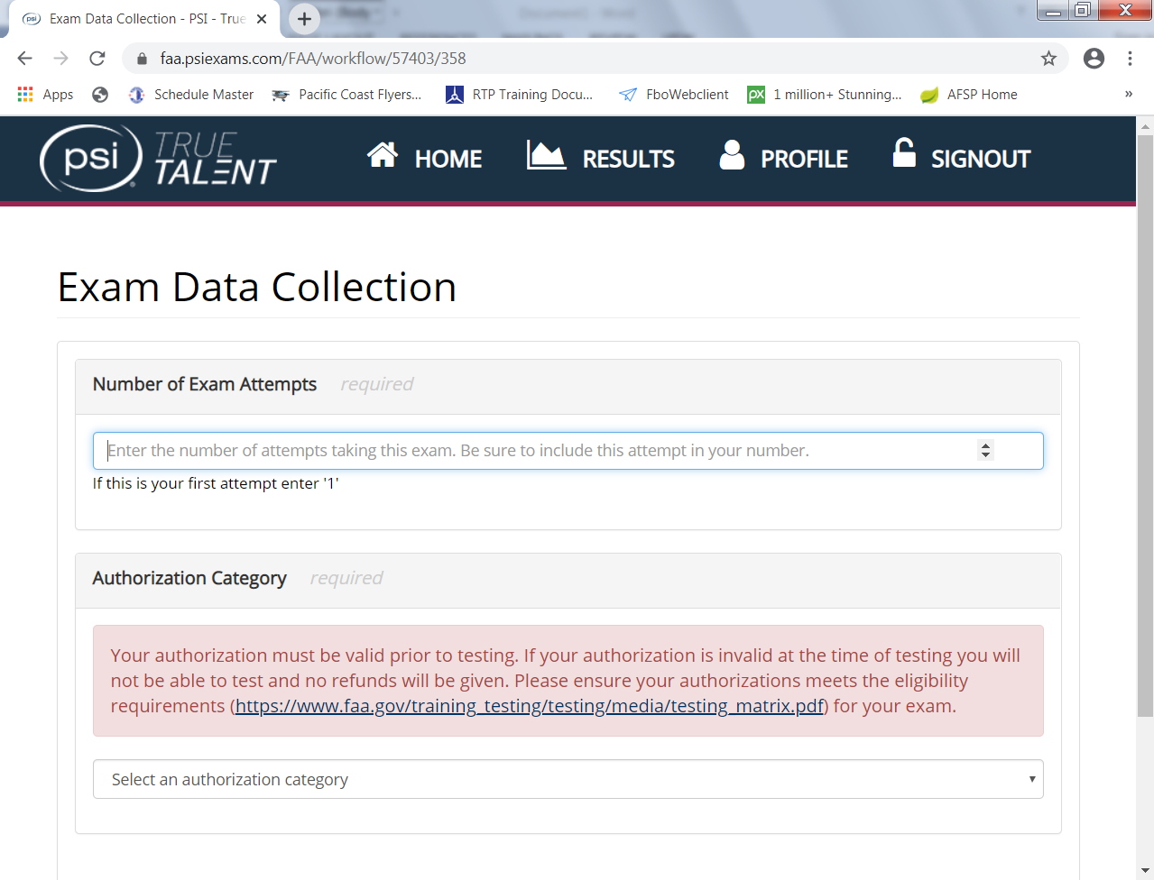

The system will take you to the **“Schedule Exam”** page enter the following:

* Country
* Postal Code, (Pinnacle - 92011)
* Distance – It defaults for 50 which should cover San Diego County.
* 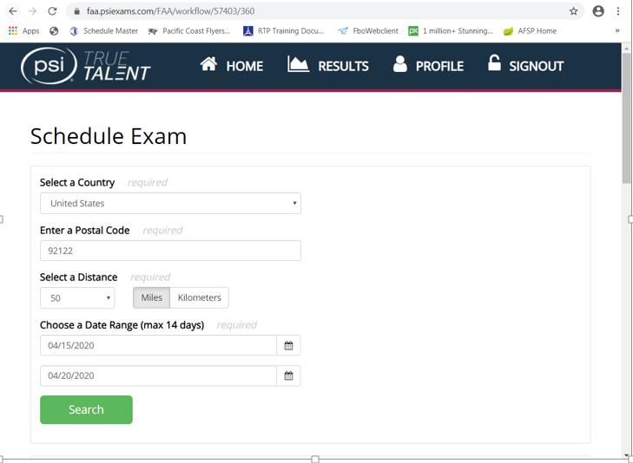Date Range

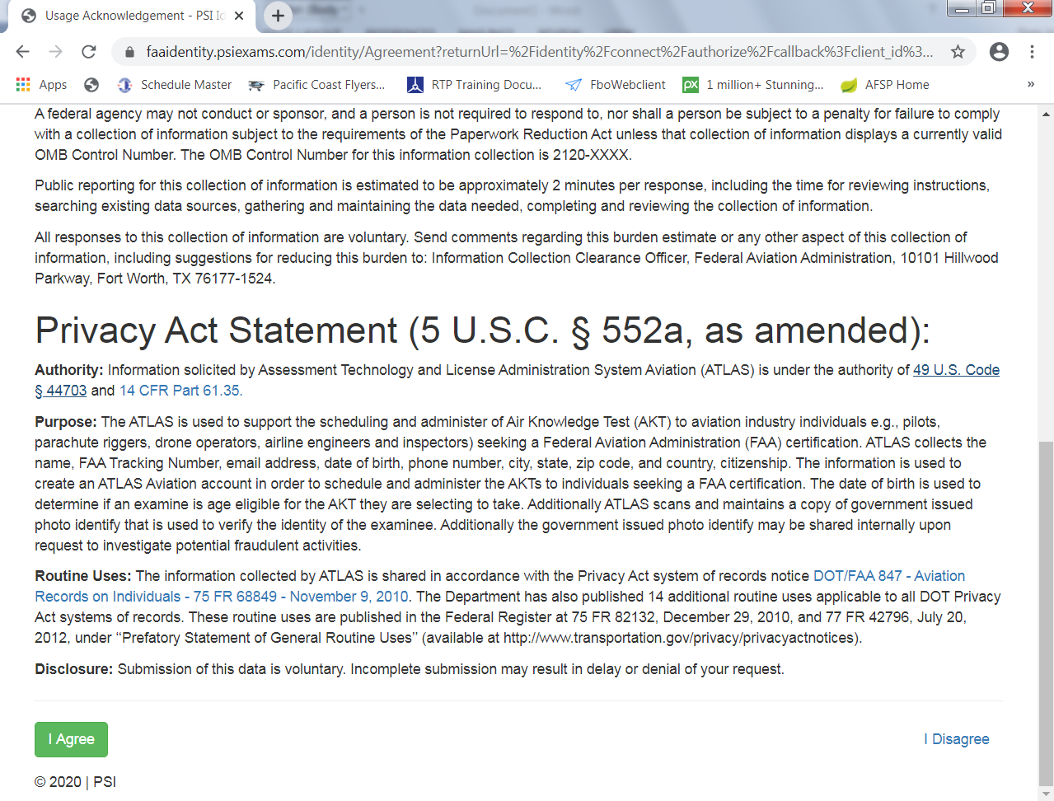  
Read the “**Privacy Act Statement”** and if all is acceptable – click on **“I Agree”**

The system will take you to the **“Payment Information and Verification Page”** to pay the exam fee.

* When logging back into the system after a reservation has been made, the system will automatically take you to the **“ACTIVE”** page. The applicant will be able to observe the DATE, TIME and LOCATION for the scheduled exam. If the applicant needs to reschedule the exam to another DATE, TIME or LOCATION, press **“DETAILS”** and follow the promps.
* Applicants can also print out a COPY of their examination results WITHOUT the embosed marking to give the COPY, NOT the origional embosed document to your instructor so it can be placed you the Students Training Folder.